Ex. No:
Date: 29-07-26
SWI Prolog
AIMdone: - To create a Prolog knowledge base containing weather details of different cities and use a rule to determine whether one city is warmer than another.

ALGORITHM:
- Start the Prolog interpreter.
- Define facts about given objects or relations.
- Define rules that describe relationships using logical implication.
- Save the program as a .pl file (e.g., weather.pl).
- Load the program using ?- [weather].
- Execute various queries using variables and constants.
- Observe and interpret the results returned by Prolog.

SOURCE CODE:
% Facts weather(vellore, hot, summer).
weather(coimbatore, warm, summer). weather(pondy, warm, winter). weather(ooty, cool, winter).
% Rule warmer_than(C1, C2) :- weather(C1, hot, summer), weather(C2, warm, summer).

OUTPUT:
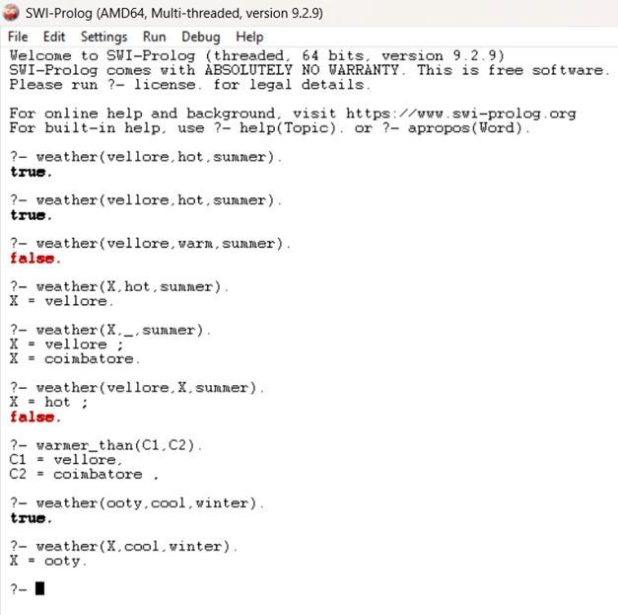

RESULT:
Hence the Program is successfully executed and the output is verified

AIMdone: - To read and print using get0 and put built-in predicate.
- To read a number and print its cube.

ALGORITHM:
- Define the players using player(X).
- Define rules for who plays chess and who is a world champion.
- Add facts about specific players (e.g., Anand).
- Define rules for matches and winning relations.
- Query the program to find players, champions, and match results.

SOURCE CODE:
player(anand). plays(X, chess) :- player(X). plays(anand, chess). playedMatch(X, Y) :- plays(X, chess), plays(Y, chess). worldChampion(X, chess) :- player(X). worldChampion(anand, chess). win(X, Y) :- playedMatch(X,Y).
beat(X, Y) :- playedMatch(X, Y), win(X, Y). beat(anand, gary).

OUTPUT:
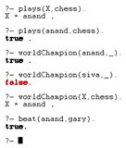

RESULT:
Hence the Program is successfully executed and the output is verified

AIMdone: - To perform basic arithmetic operations.
- To find whether a given number is odd or even.
- To find the largest of two numbers.
- To find the average of two numbers.

ALGORITHM:
- Incorporate the core I/O predicates: read/1, write/1, and writeq/1 to handle data exchange..
- Define recursive rules to continue reading and displaying characters or numbers.
- Execute and verify the output.

SOURCE CODE:
readline :- get0(X), process(X). process(13). process(X) :- X =\= 13, put(X), nl, readline.

OUTPUT:
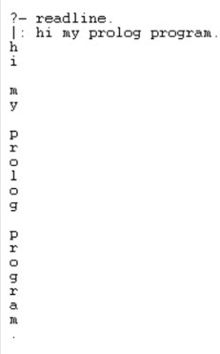

RESULT:
Hence the Program is successfully executed and the output is verified

AIMdone: - To print a given number by subtracting a value of 1 until it becomes 0.
- To print Fibonacci series.
- To find the factorial of a number.
- To check if prime or not.

ALGORITHM:
- Start the Prolog environment.
- Use read/1, write/1, and writeq/1 predicates for input and output operations.
- Use get0/1 and put/1 for character-based input/output.
- Define recursive rules to continue reading and printing characters or computing results.
- Execute and verify the output for correctness.

SOURCE CODE:

cube :- write('Write a number: '), read(Number), process(Number). process(stop) :- !.
process(Number) :- C is Number * Number * Number, write('Cube of '), write(Number), write(': '), write(C), nl, cube.

OUTPUT:
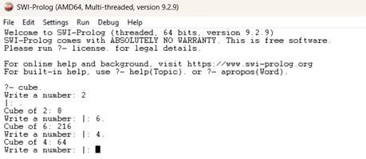

RESULT:
Hence the Program is successfully executed and the output is verified

AIM:To write Prolog programs that perform arithmetic and conditional operations using operators.

ALGORITHM:
- Define rules using arithmetic operators (+, -, *, /).
- Use mod/2 for checking even or odd numbers.
- Use max/2 to determine the largest number.
- Define formulas for average calculation.
- Execute and verify the results.

SOURCE CODE:
- arith(X,Y):-
A is X+Y, write('Sum is '), write(A), nl,
B is X-Y, write('Difference is '), write(B), nl,
C is X*Y, write('Product is '), write(C), nl,
D is X/Y, write('Quotient is '), write(D).
- oddeven(X):-mod(X,2)=:=0, write('Given number is even'); write('Given number is odd').
- largest(X,Y):-A is max(X,Y), write(A).
- average(X,Y):-Z is (X+Y)/2, write('Average is '), write(Z)

OUTPUT:
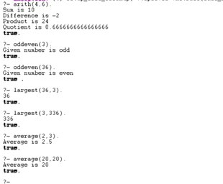

RESULT:
Hence the Program is successfully executed and the output is verified

AIM:To implement simple looping and recursive programs in Prolog such as factorial, Fibonacci, and prime number detection.

ALGORITHM:
- Start the Prolog interpreter.
- Define recursive rules for loops and computations.
- For factorial: base case N=0; recursive case N*F(N-1).
- For Fibonacci: recursively compute sum of previous two terms.
- For prime check: divide number by increasing integers and test divisibility.
- Execute and verify the output.

SOURCE CODE:
  - loop(0).
loop(N):-N>0, write(N), nl, M is N-1, loop(M).
  - fibonacci(N):-loop(N,-1,1). loop(M,A,B):-M>0,
C is A+B, write(C), nl,
G is M-1, D is B, E is C, loop(G,D,E). loop(0,D,E).
  - fac(0,1).
fac(N,F):-(N>0->(N1 is N-1, fac(N1,F1), F is N*F1); write('Enter a non-zero value')).
  - prime(X):-X>1, loop(X,2); write('Neither prime nor composite'). loop(X,I):-I=<X/2,(mod(X,I)=:=0, fin(1); J is I+1, loop(X,J)); fin(0). fin(A):-A=:=0, write('Prime'); write('Composite')

OUTPUT:

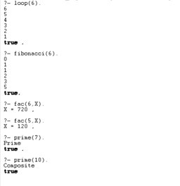

RESULT:
Hence the Program is successfully executed and the output is verified

Ex. No: 2
Date: 13-08-25
Breadth-First Search (BFS) & Depth-First Search (DFS)
AIM: To implement Breadth-First Search (BFS) and Depth-First Search (DFS) algorithms on a binary tree, locate a target element, count the number of nodes visited in each search, and compare their efficiency.

ALGORITHM:
- Start the program and create a binary tree using Node objects.
- For BFS (Breadth-First Search):
  - Use a queue to visit nodes level by level.
  - Check if the current node matches the search value.
  - Add the left and right child nodes to the queue.
  - Continue until the element is found or all nodes are visited.
- For DFS (Depth-First Search):
  - Use a stack to visit nodes depth-wise.
  - Pop the top node, check if it matches the search value.
  - Push the right and left child nodes into the stack.
  - Continue until the element is found or all nodes are visited.
- Count how many nodes are visited in both searches.
- Compare the number of visited nodes to determine which search took less time.
- Display the traversal order, whether the element was found, and the comparison result.
- End the program.

SOURCE CODE:
class Node:
def init (self, data): self.data = data self.left = None self.right = None

def bfs_search(root, target): if not root:
return 0 queue = [root] count = 0
print("BFS Traversal:", end=" ")

while queue:
node = queue.pop(0) count += 1 print(node.data, end=" ")

if node.data == target: print("\nElement Found!") return count
if node.left: queue.append(node.left)
if node.right: queue.append(node.right)

print("\nElement Not Found!") return count

def dfs_search(root, target): if not root:
return 0 stack = [root] count = 0
print("DFS Traversal:", end=" ")

while stack:
node = stack.pop() count += 1
print(node.data, end=" ")

if node.data == target: print("\nElement Found!") return count
if node.right: stack.append(node.right)
if node.left: stack.append(node.left)

print("\nElement Not Found!") return count

if name == " main ":

# Constructing binary tree:
# 10
# / \
# 20 30
# / \ \
# 40 50 60

root = Node(10) root.left = Node(20) root.right = Node(30) root.left.left = Node(40)
root.left.right = Node(50) root.right.right = Node(60)

element = 60
bfs_count = bfs_search(root, element) dfs_count = dfs_search(root, element)

print("\n--- Comparison ---") if bfs_count < dfs_count:
print("BFS visited fewer nodes → faster for this search.") elif bfs_count > dfs_count:
print("DFS visited fewer nodes → faster for this search.") else:
print("Both BFS and DFS visited the same number of nodes.")

OUTPUT:

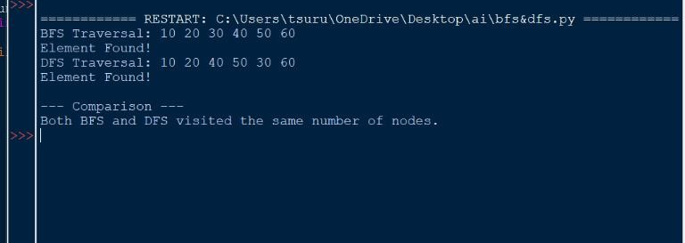

RESULT:
Hence the Program is successfully executed and the output is verified

Ex. No: 3
Date: 20-08-25
DLS (Depth-Limited Search), IDS (Iterative Deepening Search), and Bidirectional Search
AIM:To develop and compare Depth-Limited Search (DLS), Iterative Deepening Search (IDS), and Bidirectional Search algorithms for different search problems, analyzing how each technique explores the search space.

ALGORITHM:
Depth-Limited Search (DLS):
- Start with the root node and set a depth limit.
- Use a stack to perform depth-first traversal.
- Pop a node and check if it matches the goal.
- If the current depth is below the limit, push its children with incremented depth.
- Continue until the element is found or the stack becomes empty. Iterative Deepening Search (IDS):
  - Repeat DLS with depth limits increasing from 0 up to a maximum depth.
  - In each iteration, search nodes only up to the current limit.
  - Stop when the target is found or the maximum depth is reached.
  - Combine the total number of nodes visited in all iterations. Bidirectional Search:
    - Initialize two frontiers — one from the start node and one from the goal.
    - Expand nodes alternately from both directions using BFS.
    - If a common node is found between the two searches, merge the forward and backward paths.
    - Return the complete path from start to goal.

SOURCE CODE:
class Node:
def init (self, data): self.data = data self.left = None self.right = None
# Depth-Limited Search (DLS)
def depth_limited_search(root, target, limit): if not root:
return 0
stack = [(root, 0)] visited = 0
print(f"DLS (limit={limit}):", end=" ")

while stack:
node, depth = stack.pop() visited += 1 print(node.data, end=" ")

if node.data == target: print("\nElement Found!") return visited
if depth < limit: if node.right:
stack.append((node.right, depth + 1)) if node.left:
stack.append((node.left, depth + 1))

print("\nElement Not Found within depth limit.")

return visited

# Iterative Deepening Search (IDS)
def iterative_deepening_search(root, target, max_depth): total_visited = 0
print(f"IDS Traversal up to depth {max_depth}:") for depth in range(max_depth + 1):
print(f" Depth {depth}: ", end="") stack = [(root, 0)]
visited_depth = 0

while stack:
node, level = stack.pop() visited_depth += 1 print(node.data, end=" ")

if node.data == target:
print(f"\nElement Found at depth {depth}") total_visited += visited_depth
return total_visited

if level < depth: if node.right:
stack.append((node.right, level + 1)) if node.left:
stack.append((node.left, level + 1))

total_visited += visited_depth print()
print("\nElement Not Found within given depth.")

return total_visited

# Bidirectional Search
def bidirectional_search(start, goal, graph): if start == goal:
return [start]

from_start = [start] from_goal = [goal] visited_start = {start: None} visited_goal = {goal: None}

while from_start and from_goal: if from_start:
node = from_start.pop(0) for neighbor in graph[node]:
if neighbor not in visited_start: visited_start[neighbor] = node from_start.append(neighbor) if neighbor in visited_goal:
return merge_paths(visited_start, visited_goal, neighbor)

if from_goal:
node = from_goal.pop(0) for neighbor in graph[node]:
if neighbor not in visited_goal: visited_goal[neighbor] = node from_goal.append(neighbor) if neighbor in visited_start:
return merge_paths(visited_start, visited_goal, neighbor)

return None
def merge_paths(forward, backward, meet): # Construct forward path
path1 = [] node = meet
while node is not None: path1.append(node) node = forward[node]
path1.reverse() path2 = [] node = meet
while node is not None: path2.append(node) node = backward[node]

return path1, path2
if name == " main ": # Binary Tree Structure:
# 1
# / \
# 2 3
# / \ \
# 4 5 6
# / \
# 7 8
root = Node(1) root.left = Node(2) root.right = Node(3) root.left.left = Node(4)

root.left.right = Node(5) root.right.right = Node(6) root.left.left.left = Node(7) root.left.left.right = Node(8)

# Graph for Bidirectional Search graph = {
'A': ['B', 'C'],
'B': ['A', 'D'],
'C': ['A', 'E'],
'D': ['B', 'F'],
'E': ['C', 'F'],
'F': ['D', 'E']
}
print("\n===== DEPTH-LIMITED SEARCH =====")
dls_count = depth_limited_search(root, 8, 3)

print("\n===== ITERATIVE DEEPENING SEARCH =====")
ids_count = iterative_deepening_search(root, 6, 2) print("Total Nodes Visited in IDS:", ids_count)

print("\n===== BIDIRECTIONAL SEARCH =====")
path = bidirectional_search('A', 'F', graph) if path:
print("Forward Path:", path[0]) print("Backward Path:", path[1][::-1])
print("Full Path:", path[0] + path[1][1:]) else:
print("No path found between the nodes.")

OUTPUT:

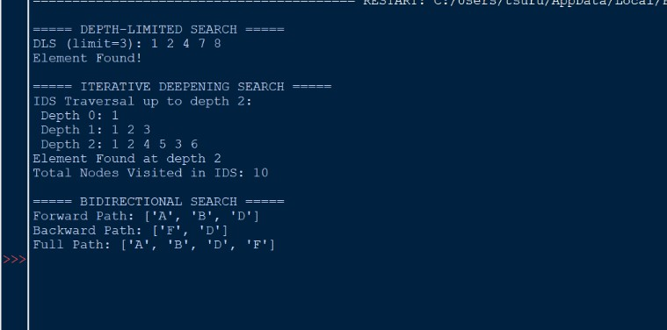

RESULT:
Hence the Program is successfully executed and the output is verified

Ex. No: 4
Date: 03-09-25
A*Algorithm
AIM:To design and implement the A* (A-star) search algorithm that determines the most cost-effective route between nodes by integrating the actual path cost and a heuristic estimate to the goal.

ALGORITHM:
- Start by inserting the start node into a priority queue with cost 𝑓 = 𝑔 + ℎ, where
  - 𝑔= actual cost from start to current node,
  - ℎ= heuristic estimate to goal.
- Remove the node having the smallest total cost 𝑓.
- If the removed node is the goal, terminate and output the path and total cost.
- Otherwise, for each neighboring node:
- Calculate new 𝑔and 𝑓values.
- If the neighbor has not been visited or a cheaper path is found, store it and push it into the priority queue.
- Repeat until the goal is reached or all nodes are visited.
- Stop the process and return the optimal path.

SOURCE CODE:
import heapq graph = {
'Arad': [('Zerind', 75), ('Sibiu', 140), ('Timisoara', 118)],
'Zerind': [('Arad', 75), ('Oradea', 71)],
'Sibiu': [('Arad', 140), ('Fagaras', 99), ('Rimnicu Vilcea', 80)],
'Timisoara': [('Arad', 118), ('Lugoj', 111)],
'Rimnicu Vilcea': [('Sibiu', 80), ('Pitesti', 97)],
'Fagaras': [('Sibiu', 99), ('Bucharest', 211)],
'Pitesti': [('Rimnicu Vilcea', 97), ('Bucharest', 101)],
'Bucharest': [('Fagaras', 211), ('Pitesti', 101)]
}
# Heuristic values (estimated straight-line distance to Bucharest) heuristic = {
'Arad': 366,
'Zerind': 374,
'Sibiu': 253,
'Timisoara': 329,
'Rimnicu Vilcea': 193,
'Fagaras': 178,
'Pitesti': 98,
'Bucharest': 0
}
def a_star(graph, start, goal, heuristic): # (f_cost, g_cost, current_node, path)
pq = [(heuristic[start], 0, start, [start])] visited = {}

while pq:

f_cost, g_cost, node, path = heapq.heappop(pq)

if node == goal:
return f_cost, g_cost, path

if node in visited and visited[node] <= g_cost: continue
visited[node] = g_cost

for neighbor, cost in graph.get(node, []): new_g = g_cost + cost
new_f = new_g + heuristic.get(neighbor, 0)
heapq.heappush(pq, (new_f, new_g, neighbor, path + [neighbor]))

return None
if name == " main ": start_city = 'Arad' goal_city = 'Bucharest'

result = a_star(graph, start_city, goal_city, heuristic)

if result:
f_cost, g_cost, path = result print("Optimal Path Found:") print(" -> ".join(path))
print(f"Total Path Cost (g): {g_cost}") print(f"Estimated Total Cost (f): {f_cost}")
else:
print("No path exists between the nodes.")

OUTPUT:

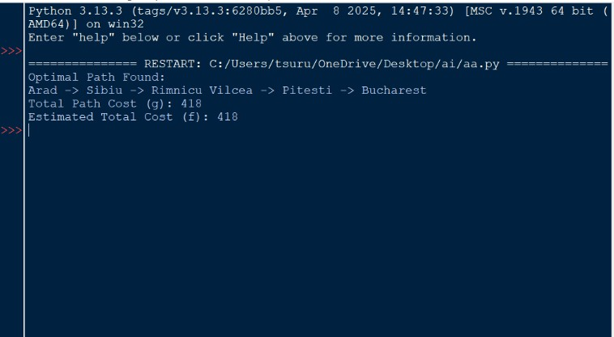

RESULT:
Hence the Program is successfully executed and the output is verified

Ex. No: 5
Date: 10-09-25

Rule-based expert system using if-then rules:
- Forward Chaining
- Backward Chaining

AIM:To develop a Python program that performs inference in a rule-based expert system using both Forward Chaining and Backward Chaining approaches to derive conclusions from given facts and rules.

ALGORITHM:
a.Forward Chaining:
- Start with a list of initial facts.
- Define a set of inference rules, each with preconditions and a conclusion.
- For each rule, check if all its preconditions exist in the known facts.
- If a rule’s conditions are satisfied and its conclusion is not already known, add the conclusion to the fact base.
- Repeat this process until no new conclusions can be inferred.
- Display the complete set of derived facts. b.Backward Chaining:
  - Take a goal or hypothesis that needs to be proven.
  - If the goal is already in the known facts, mark it as proven.
  - If not, search for rules whose conclusion matches the goal.
  - For each such rule, attempt to prove all of its preconditions recursively.
  - If all preconditions are proven true, accept the goal as valid.
  - Continue until the goal is either proven or cannot be derived from any rule.

SOURCE CODE:
# Forward Chaining Example: Healthcare Diagnosis

# Known facts (symptoms) facts = {
"cough": True, "fatigue": True,
"temperature": 101.2 # Fahrenheit
}
# Rules with condition as part of facts rules = [
{"if": {"temperature": lambda t: t > 100.4, "cough": True}, "then": "flu"},
{"if": {"temperature": lambda t: t > 102, "fatigue": True, "body_pain": True}, "then": "dengue"},
{"if": {"cough": True, "sore_throat": True}, "then": "cold"},
{"if": {"headache": True, "nausea": True}, "then": "migraine"}
]
inferred = set()
def forward_chaining(facts, rules): new_inferred = True
while new_inferred: new_inferred = False for rule in rules:
match = True
for cond, value in rule["if"].items(): if cond == "temperature":
if not value(facts["temperature"]): match = False
break
else:

if value and not facts.get(cond, False): match = False
break
if match and rule["then"] not in facts: facts[rule["then"]] = True inferred.add(rule["then"]) print(f"Inferred: {rule['then']}") new_inferred = True
return inferred

diagnosis = forward_chaining(facts, rules) print("\nPossible diagnoses:", diagnosis)

# b. Backward Chaining class BackwardChaining:
def init (self, knowledge_base): # Store rules and facts
self.knowledge_base = knowledge_base def infer(self, goal):
# If the goal is already a known fact, return True if goal in self.knowledge_base.get("facts", []):
return True
# Check rules to see if goal can be derived
for rule in self.knowledge_base.get("rules", []): if rule["then"] == goal:
# Recursively infer conditions
if all(self.infer(condition) for condition in rule["if"]): return True
return False knowledge_base = {
"facts": ["Crimea Annexation", "NATO Expansion"], # Known facts "rules": [
{"if": ["Crimea Annexation", "NATO Expansion"], "then": "Russia's Invasion"},
{"if": ["Russia's Invasion"], "then": "Ukraine-Russia War"},
] }
bc = BackwardChaining(knowledge_base) # Test backward chaining with a goal
goal = "Ukraine-Russia War" if bc.infer(goal):
print(f"The cause of {goal} is inferred from known facts.") else:
print(f"The cause of {goal} cannot be inferred.")

OUTPUT:

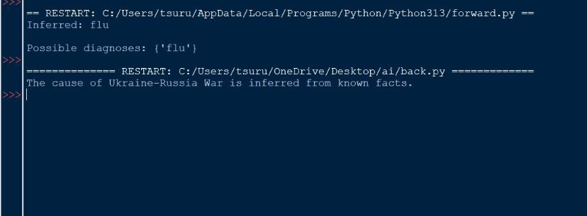

RESULT:
Hence the Program is successfully executed and the output is verified

Ex. No: 6
Date: 17-09-25
Wumpus World
AIM: To implement and simulate the Wumpus World problem in SWI-Prolog.

ALGORITHM:
- Initialize grid size, agent start, Wumpus, pits, and gold positions.
- Define adjacent cell relationships.
- Assign percepts — stench (near Wumpus), breeze (near pit), glitter (on gold).
- Check cell safety (no stench or breeze).
- Allow movements within grid limits (up, down, left, right).
- If glitter sensed → grab gold; else move to safe, unvisited cell.
- Generate and execute plan from start to goal.
- Display percepts, safety status, and path taken.

SOURCE CODE:
/*
Wumpus World in SWI-Prolog
*/
% --- World Representation ---
% world(Size, Wumpus, PitList, Gold) world(4, (2,3), [(3,1),(4,4)], (2,2)).
% --- Adjacency Helper ---adjacent((X,Y),(X1,Y)) :- X1 is X+1.
adjacent((X,Y),(X1,Y)) :- X1 is X-1, X1 > 0.
adjacent((X,Y),(X,Y1)) :- Y1 is Y+1.
adjacent((X,Y),(X,Y1)) :- Y1 is Y-1, Y1 > 0.1
% --- Percepts ---stench(Pos) :-
world(_, Wumpus, _, _), adjacent(Pos,Wumpus). breeze(Pos) :-
world(_, _, Pits, _), member(Pit,Pits), adjacent(Pos,Pit). glitter(Pos) :-world(_, _, _, Gold), Pos = Gold.
% --- Safety ---safe(Pos) :-
\+ stench(Pos),
\+ breeze(Pos).
% --- Moves (stay within world bounds) ---move((X,Y), right, (X1,Y)) :-

world(Size, _, _, _), X1 is X+1,
X1 =< Size.
move((X,Y), left, (X1,Y)) :-X1 is X-1,
X1 > 0.
move((X,Y), up, (X,Y1)) :-
world(Size, _, _, _), Y1 is Y+1,
Y1 =< Size.
move((X,Y), down, (X,Y1)) :-Y1 is Y-1,
Y1 > 0.
% --- Safe or goal (allow moving to gold even if near danger) ---safe_or_goal(Pos) :-
safe(Pos); glitter(Pos).1
% --- Planning with visited cells to avoid cycles ---plan(Start, Plan) :-
plan(Start, [Start], Plan).
% If gold is here, grab it plan(Pos, _, [grab]) :-glitter(Pos), !.
% Explore safe neighbors plan(Pos, Visited, [Move|Rest]) :-move(Pos, Move, Next), safe_or_goal(Next),
\+ member(Next, Visited), plan(Next, [Next|Visited], Rest).

OUTPUT:

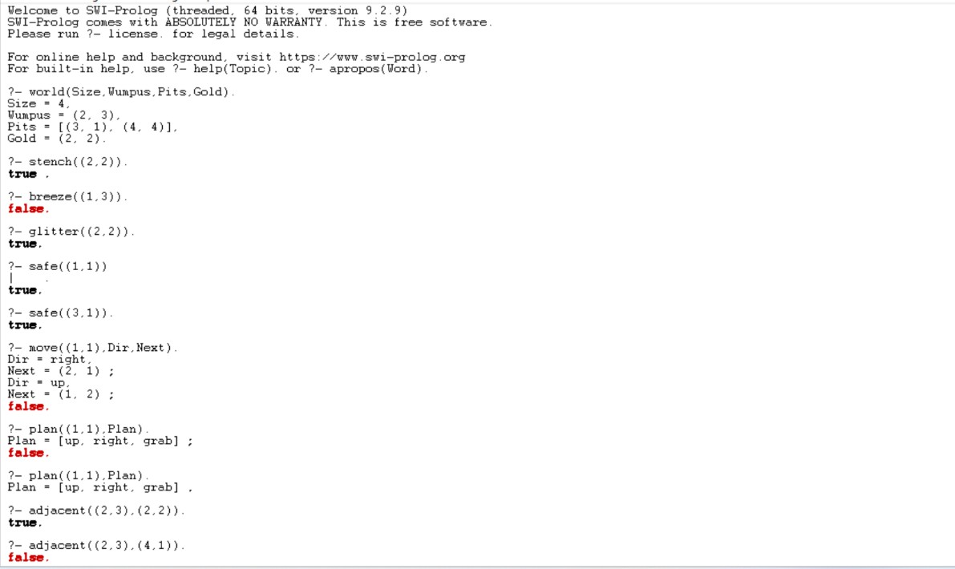

RESULT:
Hence the Program is successfully executed and the output is verified

Ex. No: 7
Date: 24-09-25
Forward and Backward chaining using propositional logic
AIM:To develop a Prolog program that applies data-driven (forward chaining) and goal-driven (backward chaining) reasoning methods to infer new knowledge from existing facts and rules.

ALGORITHM:
Backward Chaining:
- Begin with a target goal that needs to be proven.
- Look for rules whose conclusions match the goal.
- Verify whether all conditions of that rule are true.
- If a condition is unknown, treat it as a new goal and attempt to prove it recursively.
- When all required conditions are verified, the original goal is considered true.
- If no applicable rules remain, conclude that the goal cannot be proven. Forward Chaining:
  - Start with a set of initial facts in the knowledge base.
  - Continuously scan through the rules.
  - Whenever all conditions of a rule are satisfied, add its conclusion as a new fact.
  - Keep updating the knowledge base until no further inferences can be made.
  - End the process when no new facts can be generated.

SOURCE CODE:
- Backward Chaining male(albert). male(edward). female(alice). female(victoria).
parents(edward, victoria, albert). parents(alice, victoria, albert).
11
sister(X,Y) :-female(X), parents(X,M,F),
parents(Y,M,F), not(X=Y).
- Forward Chaining
% Facts
:- dynamic fact/1. fact(sun_is_shining). fact(it_is_day).
% Rules
rule([sun_is_shining, it_is_day], it_is_bright). rule([it_is_bright], go_outside).
% Forward chaining engine forward_chain :-new_fact(F),
\+ fact(F), assert(fact(F)),
write('Derived: '), writeln(F), forward_chain.

forward_chain :- !. new_fact(F) :-rule(Conditions, F), all_true(Conditions). all_true([]).
all_true([H|T]) :-fact(H), all_true(T).

OUTPUT:
- Backward Chaining Output

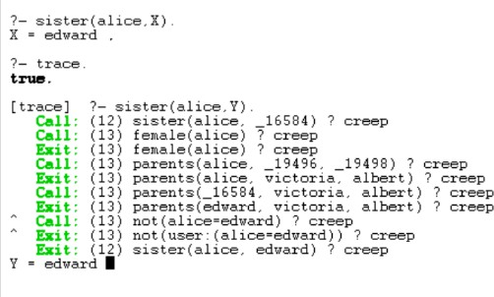

- Forward Chaining Output

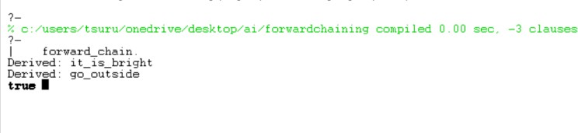

RESULT:
Hence the Program is successfully executed and the output is verified

Ex. No: 8
Date: 24-09-25
Linear Regression
AIM: To build and train a simple Linear Regression model using Gradient Descent in Python for predicting continuous values.

ALGORITHM:
  - Import necessary libraries (numpy, pandas, matplotlib).
  - Load and preprocess the dataset.
  - Initialize slope (m), intercept (b), learning rate, and iteration count.
  - Define Mean Squared Error (MSE) as the loss function.
  - Apply Gradient Descent to update m and b iteratively to minimize loss.
  - Repeat updates until convergence or maximum epochs are reached.
  - Plot the best-fit regression line and loss curve.

SOURCE CODE:
import pandas as pd import numpy as np
import matplotlib.pyplot as plt
data = pd.read_csv('studytime_scores.csv') data['StudyTime_Hours_Norm'] = data['StudyTime_Hours'] / data['StudyTime_Hours'].max()
def loss_function(m, b, points):
total_error = 0
for i in range(len(points)):
x = points.iloc[i].StudyTime_Hours_Norm y = points.iloc[i].ExamScore
total_error += (y - (m*x + b))**2 return total_error / float(len(points))
def gradient_descent(m_now, b_now, points, L): m_gradient = 0
b_gradient = 0 n = len(points)
for i in range(n):
x = points.iloc[i].StudyTime_Hours_Norm y = points.iloc[i].ExamScore
m_gradient += -(2/n) * x * (y - (m_now*x + b_now)) b_gradient += -(2/n) * (y - (m_now*x + b_now))
m = m_now - L * m_gradient b = b_now - L * b_gradient return m, b
m = 0
b = 0
L = 0.01
epochs = 2000

loss_history = []1
for i in range(epochs+1):
m, b = gradient_descent(m, b, data, L) current_loss = loss_function(m, b, data) loss_history.append(current_loss)
if i % 200 == 0:
print(f"Epoch {i}: m={m:.6f}, b={b:.3f}, loss={loss_function(m,b,data):.3f}") print(f"\nFinal model: y = {m:.6f}x + {b:.3f}") plt.figure(figsize=(12,5))
plt.subplot(1, 2, 1)
plt.scatter(data.StudyTime_Hours_Norm, data.ExamScore, color="black", label="Data points")
x_range = np.linspace(data.StudyTime_Hours_Norm.min(), data.StudyTime_Hours_Norm.max(), 100)
plt.plot(x_range, m*x_range + b, color="red", label="Regression line") plt.xlabel("Normalized Study Time")
plt.ylabel("Exam Score") plt.title("Linear Regression Fit") plt.legend()
plt.subplot(1, 2, 2)
plt.plot(range(epochs+1), loss_history, color='blue') plt.xlabel("Epochs")
plt.ylabel("Loss (MSE)") plt.title("Loss vs Epochs") plt.tight_layout() plt.show()

OUTPUT:
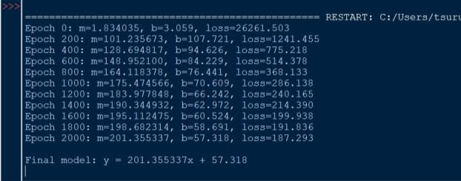

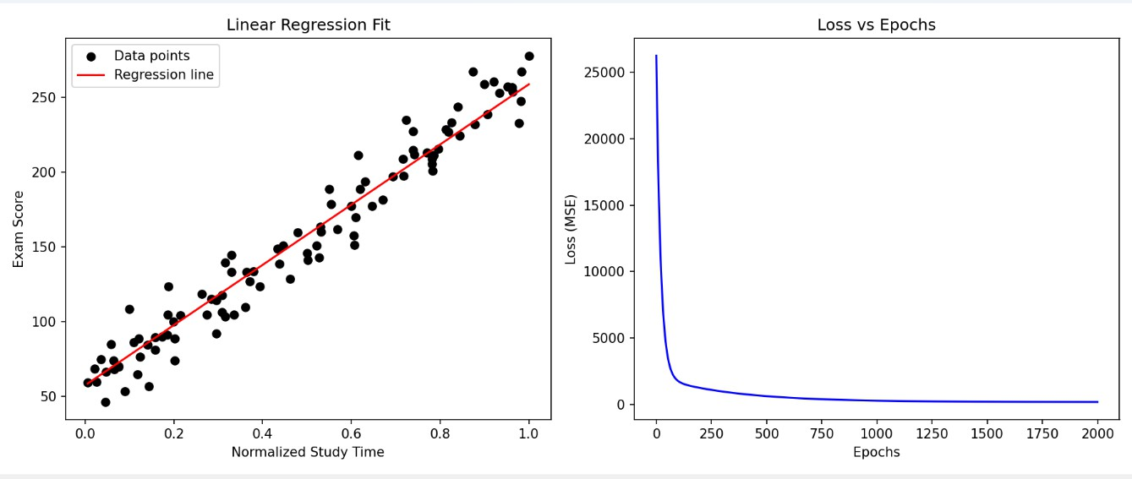

RESULT:
Hence the program is successfully executed and the output is verified.

Ex. No: 9
Date: 22-10-25
Decision Tree
AIM:To construct and implement a Decision Tree classifier in Python using the ID3 algorithm for classifying categorical data based on information gain and entropy.

ALGORITHM:
- Compute the entropy of the target attribute to measure impurity.
- For each feature, calculate Information Gain to identify the best splitting attribute.
- Select the attribute with the highest Information Gain as the decision node.
- Partition the dataset according to the chosen attribute’s values.
- Recursively repeat the process on each subset until all instances are pure or no attributes remain.
- Use the constructed tree to classify new data samples by traversing nodes based on their attribute values.

SOURCE CODE:
import pandas as pd import math

# Load dataset
data = pd.read_csv("buy_computer.csv")

# Calculate entropy of a given attribute def calculate_entropy(df, target):
entropy_val = 0 total = len(df)
for val in df[target].unique():
p = len(df[df[target] == val]) / total if p > 0:
entropy_val -= p * math.log2(p) return entropy_val

# Calculate information gain for a given attribute def calculate_info_gain(df, feature, target):
total_entropy = calculate_entropy(df, target) weighted_entropy = 0
total = len(df)
for val in df[feature].unique(): subset = df[df[feature] == val] weight = len(subset) / total
weighted_entropy += weight * calculate_entropy(subset, target) return total_entropy - weighted_entropy
def build_tree(df, target, features): if len(df[target].unique()) == 1:

return df[target].iloc[0] if not features:
return df[target].mode()[0]

gains = {feature: calculate_info_gain(df, feature, target) for feature in features} best_feature = max(gains, key=gains.get)
tree = {best_feature: {}}

for val in df[best_feature].unique(): subset = df[df[best_feature] == val]
remaining_features = [f for f in features if f != best_feature] tree[best_feature][val] = build_tree(subset, target, remaining_features)

return tree

# Predict the class for a new sample def classify(tree, sample):
if not isinstance(tree, dict): return tree
feature = next(iter(tree))
if sample[feature] in tree[feature]:
return classify(tree[feature][sample[feature]], sample) else:
return None

# Main execution
features = list(data.columns) features.remove('buys_computer')

decision_tree = build_tree(data, 'buys_computer', features)

print("Generated Decision Tree:") print(decision_tree)

new_case = { 'age': 'youth',
'income': 'medium',
'student': 'yes', 'credit_rating': 'excellent'
}
prediction = classify(decision_tree, new_case)

print("\nNew Case:", new_case) print("Predicted Output:", prediction)

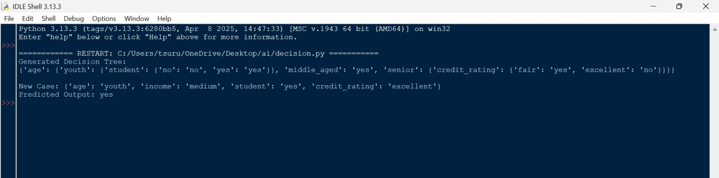
OUTPUT:

RESULT:
Hence the Program is successfully executed and the output is verified

Ex. No: 10
Date: 22-10-25
K-Means
AIM:To develop a Python program that applies the K-Means clustering algorithm to divide a dataset into k groups by iteratively refining cluster centroids to minimize the distance between data points and their respective cluster centers.

ALGORITHM:
- Start
- Import the required Python libraries (numpy, matplotlib).
- Load or define the dataset containing data points.
- Choose the number of clusters (k) and initialize centroids randomly or by selecting data points.
- For each data point, calculate the Euclidean distance to each centroid and assign the point to the nearest centroid.
- Recalculate each centroid as the mean of all points assigned to that cluster.
- Repeat steps 5 and 6 until centroids no longer change or a maximum number of iterations is reached.
- Display the final centroids and visualize the clustered data points.
- Stop

SOURCE CODE:
import numpy as np
import matplotlib.pyplot as plt

# Step 1: Initialize dataset
data = np.array([[1, 2], [1.5, 1.8], [5, 8], [6, 9]])
k = 2 # Number of clusters

# Step 2: Randomly choose initial centroids np.random.seed(0)
centroids = data[np.random.choice(data.shape[0], k, replace=False)]

def assign_clusters(points, centers):
"""Assign each point to the nearest centroid."""
distances = np.linalg.norm(points[:, np.newaxis] - centers, axis=2) return np.argmin(distances, axis=1)

def update_centroids(points, labels, k): """Recalculate centroid positions."""
new_centers = np.array([points[labels == i].mean(axis=0) for i in range(k)]) return new_centers

# Step 3: Iterate until convergence or max iterations for iteration in range(10):
cluster_labels = assign_clusters(data, centroids) updated_centroids = update_centroids(data, cluster_labels, k)

# Visualization
plt.scatter(data[cluster_labels == 0, 0], data[cluster_labels == 0, 1], c='blue', label='Cluster 1')
plt.scatter(data[cluster_labels == 1, 0], data[cluster_labels == 1, 1], c='orange', label='Cluster
2')
plt.scatter(updated_centroids[:, 0], updated_centroids[:, 1], c='black', marker='X', s=200, label='Centroids')
plt.title(f'K-Means Iteration {iteration + 1}') plt.legend()
plt.show()

print(f"Iteration {iteration + 1}:") print("Cluster Labels:", cluster_labels) print("Centroids:\n", updated_centroids, "\n")

# Check for convergence
if np.allclose(centroids, updated_centroids): break
centroids = updated_centroids

print("Final Centroids:\n", centroids)

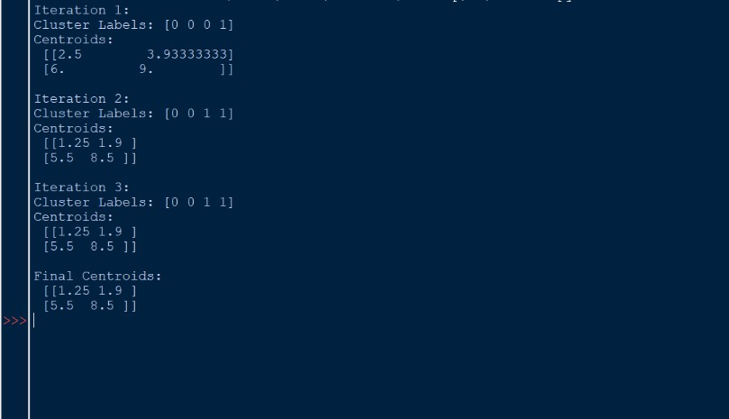
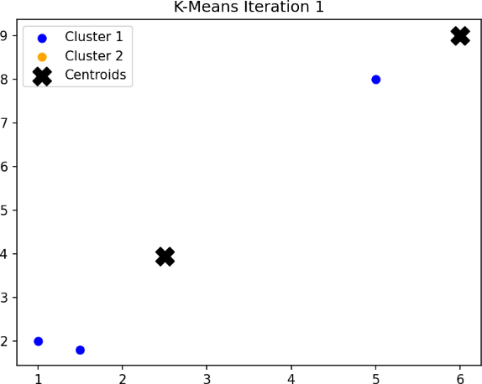
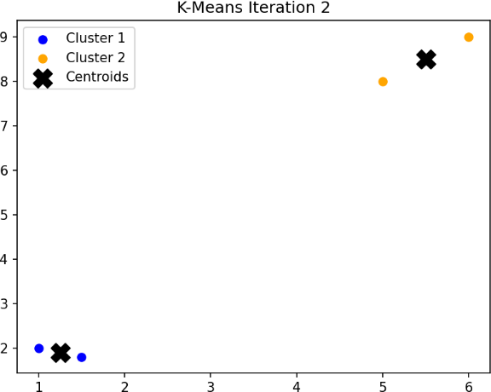
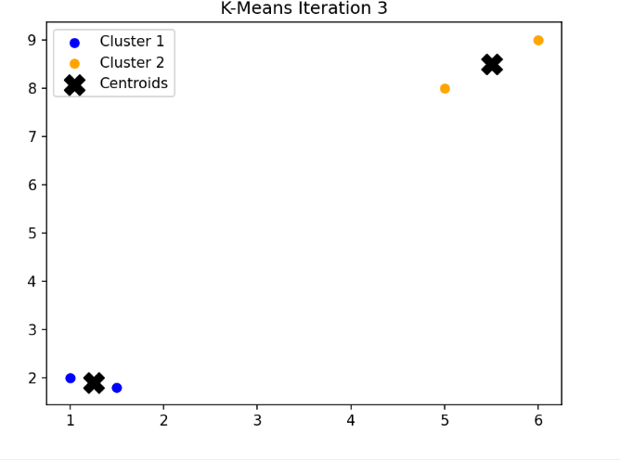
OUTPUT:

RESULT:
Hence the Program is successfully executed and the output is verified

Ex. No: 11
Date: 29-10-25
Perform Principal Component Analysis (PCA)

AIM:
To implement Principal Component Analysis (PCA) from scratch to reduce the dimensionality of a high-dimensional dataset and represent the data in two principal components for visualization.

ALGORITHM:
- Import the necessary libraries: NumPy and Matplotlib.
- Create a multidimensional dataset with several correlated features.
- Normalize the dataset by centering each feature around its mean.
- Compute the covariance matrix of the standardized dataset.
- Determine the eigenvalues and corresponding eigenvectors of the covariance matrix.
- Sort the eigenvalues in descending order and rearrange the eigenvectors accordingly.
- Choose the top k eigenvectors to form the principal components.
- Project the original dataset onto the new principal component axes to obtain reduced data.
- Display the reduced feature dimensions and visualize the result in 2D space.

SOURCE CODE:
import numpy as np
import matplotlib.pyplot as plt

# Step 1: Create a dataset (4 features) data = np.array([
[2.6, 2.5, 1.7, 0.8],
[0.6, 0.8, 0.9, 0.2],
[2.3, 3.1, 2.0, 1.8],
[1.8, 2.3, 1.5, 1.0],
[3.0, 2.8, 2.8, 2.4],
[2.2, 2.6, 2.1, 1.6],
[1.9, 1.8, 1.6, 1.3],
[1.2, 1.0, 0.7, 0.4],
[1.6, 1.5, 1.2, 0.8],
[1.0, 0.7, 0.9, 0.3]
])

# Step 2: Standardize data (mean centering) mean_centered = data - np.mean(data, axis=0)

# Step 3: Compute covariance matrix
covariance_matrix = np.cov(mean_centered, rowvar=False)

# Step 4: Find eigenvalues and eigenvectors
eig_vals, eig_vecs = np.linalg.eigh(covariance_matrix)

# Step 5: Sort eigenvalues (descending) and reorder eigenvectors sorted_indices = np.argsort(eig_vals)[::-1]
eig_vals = eig_vals[sorted_indices] eig_vecs = eig_vecs[:, sorted_indices]

# Step 6: Choose top 2 principal components k = 2
top_components = eig_vecs[:, :k]

# Step 7: Project data onto new subspace
reduced_data = np.dot(mean_centered, top_components)

# Step 8: Print results
print("Original Data Shape:", data.shape) print("Reduced Data Shape:", reduced_data.shape) print("Eigenvalues:", np.round(eig_vals, 3))
print("Explained Variance (%):", np.round(eig_vals / np.sum(eig_vals) * 100, 2))

# Step 9: Visualization plt.figure(figsize=(7,5))
plt.scatter(reduced_data[:, 0], reduced_data[:, 1], color='green', edgecolor='black') plt.title("PCA Result (2D Projection)")
plt.xlabel("Principal Component 1")
plt.ylabel("Principal Component 2") plt.grid(True)
plt.show()

OUTPUT:

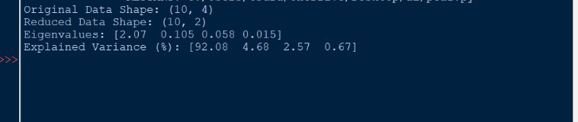

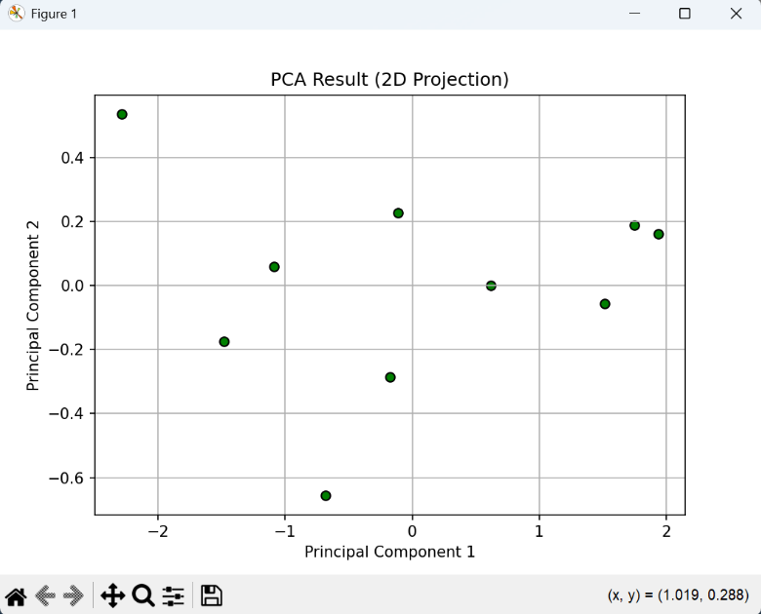

RESULT:
Hence the Program is successfully executed and the output is verified

Ex. No: 12
Date: 29-10-25
Basic Neural Network using TensorFlow for classification
AIM:To implement a Basic Neural Network using TensorFlow for predicting output values based on a simple linear relationship between input and output data.

ALGORITHM
- Import the required libraries — TensorFlow, Keras, NumPy, and Matplotlib.
- Prepare the training data (X_train, y_train) for a simple linear relationship.
- Define a Sequential neural network model with one dense (fully connected) layer.
- Compile the model using the Adam optimizer and Mean Squared Error (MSE) as the loss function.
- Train the model using the training data for a specified number of epochs (iterations).
- Predict the output for a new input value using the trained model.
- Plot the training loss curve to visualize how the model improved over epochs.
- Display the model summary showing the number of parameters (weights and bias).

SOURCE CODE:
import tensorflow as tf
from tensorflow import keras import numpy as np
import matplotlib.pyplot as plt

# 1. Prepare Data
X_train = np.array([-1.0, 0.0, 1.0, 2.0, 3.0, 4.0], dtype=float)
y_train = np.array([-1.0, 1.0, 3.0, 5.0, 7.0, 9.0], dtype=float)

model = keras.Sequential([keras.layers.Dense(1, input_shape=(1,))]) model.compile(optimizer='adam', loss='mean_squared_error') print("Training the model...")
history = model.fit(X_train, y_train, epochs=500, verbose=0) print("Training complete.")
new_x = 10.0
predicted_y = model.predict(np.array([[new_x]], dtype=float))[0][0] print(f"Prediction for x = {new_x}: {predicted_y:.2f}")

# 6. Plot Loss plt.plot(history.history['loss']) plt.title('Model Training Loss') plt.xlabel('Epochs') plt.ylabel('Loss')
plt.show()

# 7. Model Summary model.summary()

OUTPUT:

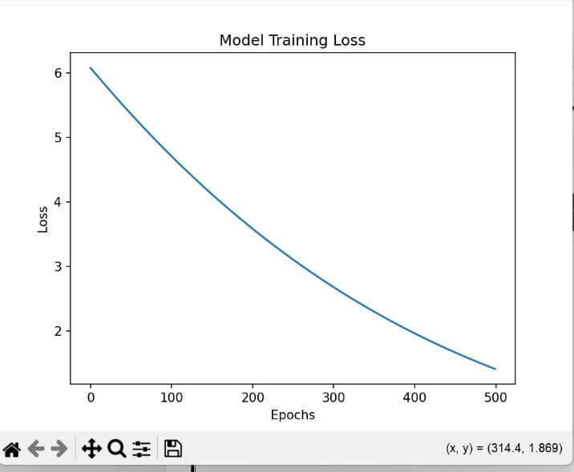

RESULT:
Hence the Program is successfully executed and the output is verified

